Enhanced embargoed Research functionality

Contents
Quick Guide to New Features 3
Company Research Page 3
Restricted Report processing 3
Table of Contents Page 3
Advanced Research Page 3
Watchlist Page 3
Detailed Guide to New Features 4
Company Research 4
New search features 4
Results Display 5
Document processing 5
Viewing reports 6
Advanced Research 8
Settings 10
Watchlist Page 10
Frequently Asked Questions 11

Quick Guide to New Features
On October 7th 2013 we will be updating the Research Company, Advanced and Watchlist pages on ThomsonONE with a new design and enhanced functionality. The Quick Guide provides a brief overview; please use the hyperlinks to view full details.

Company Research Page
Availability Date – this uses the date that the report has been released from embargo. Use this date to pull the latest reports available on your company.
Primary Company Checkbox – Restricts the search to the company that is the main focus of the report.
Suppressed Brokers - Replaces the current Non-Broker Research link. It enables you to modify the non-broker list by adding your own brokers to restrict or by removing non-brokers that you would like to include in your search
Favorite Brokers - clicking the red down arrow by Suppressed Brokers returns a menu with the option of setting favorite brokers as a filter on your search.
New Collection Tabs - Separate tabs at the top of the results display allow users to view any Real-Time or Internal Research to which they are entitled.
For more details on the Company Page enhancements click here.

Restricted Report processing
The new Cart function enables users to select useful reports they wish to view and store them in a collection until they are ready to be reviewed. Users may request access to restricted reports from the Cart and Administrators can approve them from their Cart without needing to search, download and send them as they do today. Note: This functionality is not available to Pooled/Express users and their administrators will see a limited version of the Cart.
For more details on the Cart click here.

Table of Contents Page
The updated table of contents is larger, enabling more of the table to be viewed without needing to scroll. It also includes thumbnails of each page to display the availability of graphs and charts, and a broker supplied synopsis of the report where available
For more details on the Table of Contents click here.

Advanced Research Page
Industry codes - have been updated to Thomson Reuter Business Categories and are applied by the analysts and reviewed using text scanning software. SIC and NAIC codes will no longer be supported on the research pages.
Starmine Analysts - a new filter enables users to search for research by only 4 and 5 star Starmine analysts
Filters - search results can be narrowed down using the new filters detailed on the Company Search page
For more details on the Advanced Page click here.

Watchlist Page
The Watchlist page includes an option to sort results by company name and by industry
For more details on the Watchlist Page click here.

Please go to the FAQ section for additional information.

Detailed Guide to New Features

Company Research
The Company Research page replaces the current Company Research page under the Company Views section of the ThomsonONE.com framework. It works in the same way as the current page in that it takes company context from the company entered in the framework search box.

New search features
Availability Date – this uses the date that the report has been released from embargo. Use this date to pull the latest reports available on your company. Report date refers to the publish date on the report

Primary Company Checkbox –Restricts the search to the company that is the main focus of the report. We are now indexing all the companies that are mentioned in a report, rather than just the focus company as we have done until now. Un-check this box to find reports where the company in context is given a secondary mention. This is useful for locating comments on smaller or private companies which may not usually be covered by brokers

Report Types – click this link to limit searches to Fixed Income or Research Digest reports. Digests are summary briefs which provide a high level comment on items such as share price changes and upcoming results releases for a list of companies

Filters – click this link to limit searches to reports that contain an Estimate Revision or to locate Initiating Coverage reports

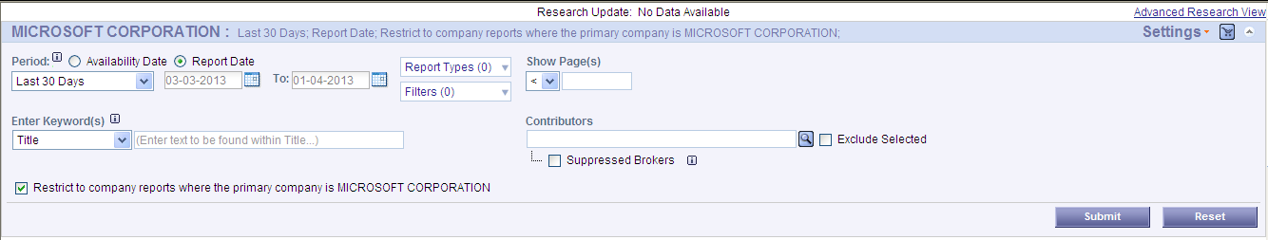

Suppressed Brokers - Replaces the current Non-Broker Research link. It enables you to modify the non-broker list by adding your own brokers to restrict or by removing non-brokers that you would like to include in your search

Favorite Brokers - clicking the red down arrow by Suppressed Brokers returns a menu with the option of setting favorite brokers as a filter on your search.

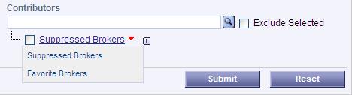

Favorite brokers are adding by clicking on the broker name in the results section or through the Preferences Menu (more on this later).

Results Display
New Collection Tabs - Separate tabs at the top of the results display allow users to view any Real-Time or Internal Research to which they are entitled:
- Real Time Research –This tab is available only for companies who are entitled to access certain research on a real-time basis. These users can now access this research on the same page as the embargoed research and so no longer need to navigate to a separate page
- Internal Research – Companies who are contributing broker research to the Thomson Reuters research collection are able to see their own research on a real-time basis on this tab as well as on the All tab co-mingled with the other collections. Users can chose to remove Internal research from the All tab via Preferences
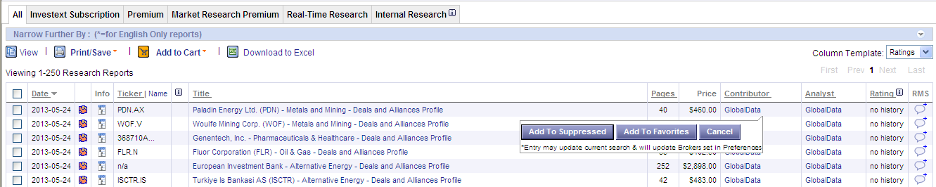

Favorite Analysts and Suppressed Brokers – customized lists can be created from the results section by clicking on the Contributor or Analyst names and adding them to a favorite or suppressed list. These lists can then be used to filter searches (see details above). Note that in the case of the Favorite Analyst, the analyst’s name will appear in bold in the results grid – this function does not search just on the favorite analyst list.

Collection Icons – These indicate the collection to which reports belong: Premium and Market Research Premium, Real Time (for those entitled), Restricted and Investext Subscription.

Ticker – Reuter RIC tickers are displayed by default in the results section. Hover over the ticker to view the company names in the report or click the Name hyperlink to toggle to the company name

Document processing
Cart – this enables you to “collect” reports of interest and print or download at one time instead of viewing them as you go. The Cart also processes requests for restricted reports.

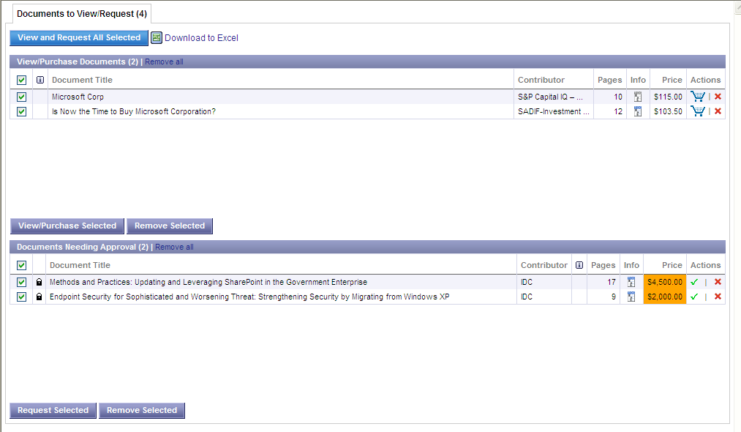

The Cart includes one or two sections depending on whether your Administrator has restricted access to certain reports. The top section displays reports that you have collected and are able to view and print. The lower section lists reports that you have collected that the Administrator has restricted. You can select these reports from the Cart and click the Request Selected button for the request to be sent to your Administrator.

Administrator Cart – includes a tab listing all reports that have been requested. The Administrator can approve or deny the report using the Action links. Once approved a notification email is sent to the user and the document is moved to the Download section of their Cart with an indicator icon confirming the user can view the report. The Administrator no longer needs to search and download the reports and send them to the requestor.

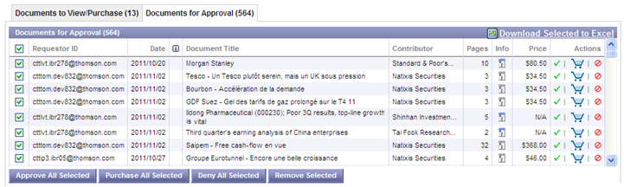

If a report is denied the user will receive an email notifying them of the denial and an icon will appear in their Cart next to the report identifying it as a rejected request.

Note:

- Administrators of Pooled Solution users can buy reports from their Carts and email them to users, but cannot use the Approve or Deny functions.
- Items in the cart will be removed automatically after 30 days if no action is taken to buy/download them

Viewing reports
Table of Contents - The Table of Contents now includes an option to view a thumbnail snapshot of each page so you can identify the level of detail on each page, particularly relating to graphs and charts

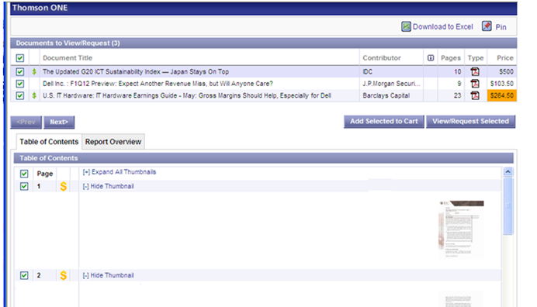

The Report Overview section includes a synopsis of the content of the report submitted by the broker (where available).

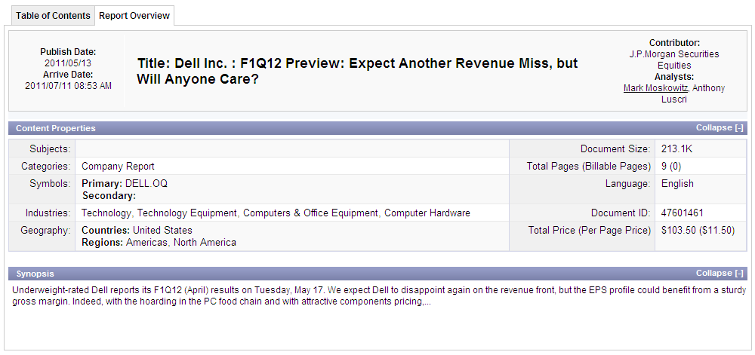

Reports or pages of reports can be viewed directly from the Table of Contents or added to the Cart.

Advanced Research
This page replaces the existing Advanced Research page under the Screening and Analysis section for Investment Banking users. Corporate Business Intelligence users will find the page under Research & News. All the existing search features have been retained and we have added the new features listed below:

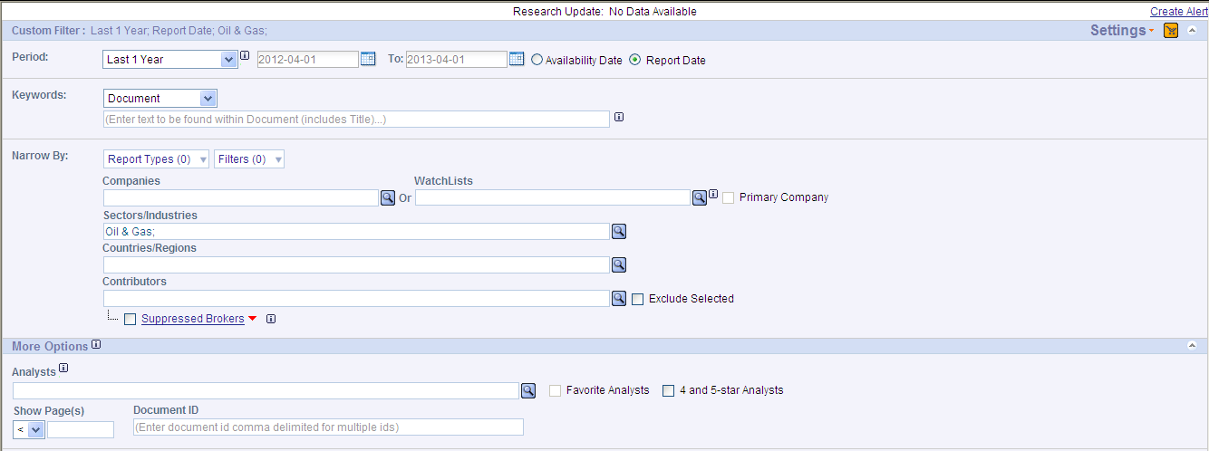

Industry classification
Thomson Reuters Industry Classification codes have replaced the SIC and NAIC codes previously used to search research. There are 4 levels of code available and they will be used by the contributors when submitting industry related research. Industry code lookups are available on the pages both as a pop-up and using the “auto-type feature” – both examples below:

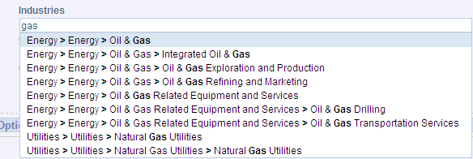

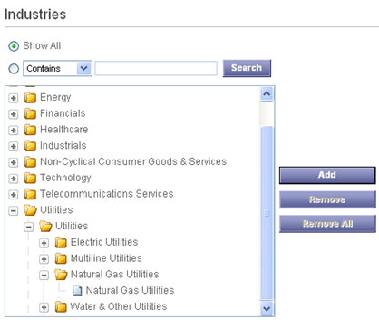

Filter on Favorite and 4 and 5 Star Analysts - Searches can be filtered to focus on reports published by your Favorite Analysts, or to retrieve reports by analysts given a 4 or 5 star rating by our Starmine team. Details of how these ratings are applied are available on the Ratings pop-up in the results column.
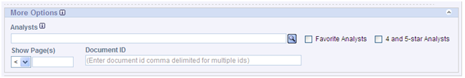

Narrow Search by Report Type - The Report Types and Filters listed in the drop down menus on this and the Company page can also be used to fine tune a search by checking the options on the banner above the results grid. In this example the search was filtered down from 54 to 7 reports containing an estimates revision:
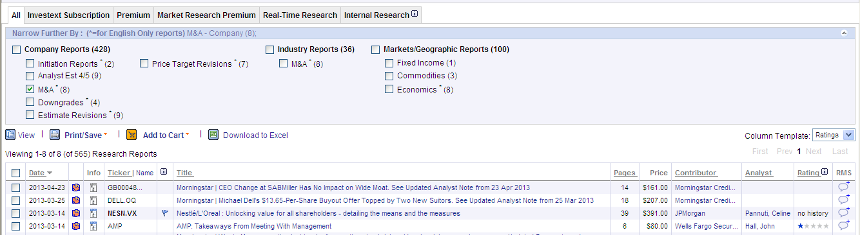

Settings
The Settings drop down includes options to set Preferences and to manage and execute Saved Searches. Users can specify Saved Searches which can be shared with colleagues at the same firm.

Only users with access to Real Time research will see the Contributor Entitlements page where they can submit a request for access to a specific broker.

Table of Contents display preferences and lists of Favorite Analysts and Suppressed Brokers are setup from the Research Preferences page.
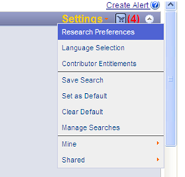

Note: Pooled/Express solution users will see a limited version of the Settings Menu.

Watchlist Page
This page functions in the same way as the Company Page except it takes context from the Watchlist entity manager on the framework. Results can be grouped by Company and Industry for a quick high level glance at how the results are categorized.

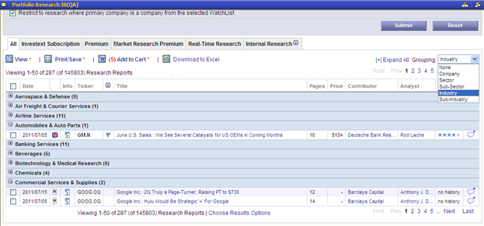

Note: Watchlist functionality is not available for Pooled/Express users who do not have a fixed, individually assigned User ID.

Frequently Asked Questions

- I have searches and preferences saved on the current Research page, will I need to re-create them on the new page?
- The majority of saved searches and all preferences will be migrated for you as you login to any of the new pages for the first time. A pop-up migration wizard will walk you through a confirmation process and will load your saved preferences and searches to the new pages. The former SIC/NAIC industry codes will be mapped to the Thomson Reuter codes. Note that Analyst Names will not be migrated since they have been standardized so you will need to set these up again on the new page.
Other changes:

- Some date ranges have been modified since not all are available on the new pages
  - 14 days has been mapped to 7 days
  - 60 days has been mapped to 90 days
  - 5 years has been mapped to 2 years
- Company level searches will be migrated with the Primary Company checkbox clicked on. If you want to include all mentions of your company in the search just uncheck that box and re-save the search.
Q. I have saved alerts on the current research page, will I need to re-create them on the new page
A. No, all existing alerts will be unaffected by the release of the new Research pages

Q. I am an Administrator, are there changes to the Administrator page?
A. A new feature has been added which enables Administrators to manage restricted brokers across their Firm. Brokers that you have requested to be removed from the broker lookup and from users searches will be visible in this section and you can now manage this list yourself. For more details on this and the new restricted ordering function please contact your account manager and request a copy of the updated Administrator User Guide

Q: Does the new view support free text search on non-English terms?
A: Yes, these are supported

Q: Are there any changes to the terms used in the free text search function?
A: The same Boolean operators and wildcards apply. Please view the search tips by the free text search page to help composing your search.
Note that exact phrases should be used with quotes – ie “market share” to ensure order and proximity are respected.

© 2013 Thomson Reuters. All rights reserved.  Republication or redistribution of Thomson Reuters content, including by framing or similar means, is prohibited without the prior written consent of Thomson Reuters. 'Thomson Reuters' and the Thomson Reuters logo are registered trademarks and trademarks of Thomson Reuters and its affiliated companies. |  | For more information  Send us a sales enquiry at  thomsonreuters.com/about/contact us  Read more about our products at  thomsonreuters.com/products_services  Find out how to contact your local office  thomsonreuters.com/about/locations

